Excel Format

1)Full Name - Grade: Standard list

Teacher’s List | Registrar List
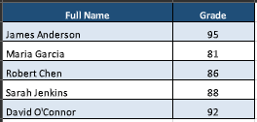 | 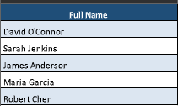

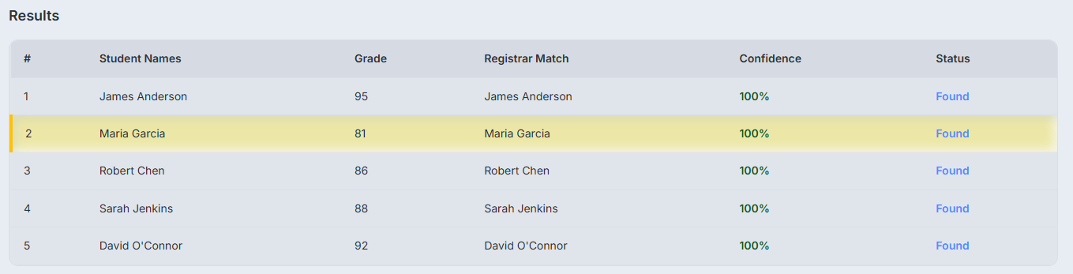

2)Split Names: First and Last Name in separate columns

Teacher’s List | Registrar List
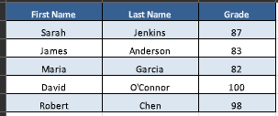 | 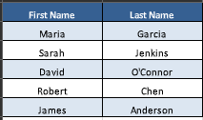

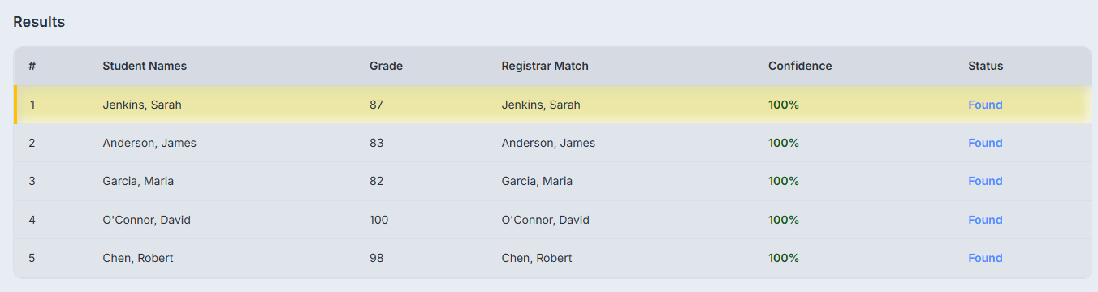

3) Grade First: Leading with the numeric grade (Green theme).

Teacher’s List | Registrar List
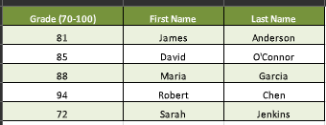 | 

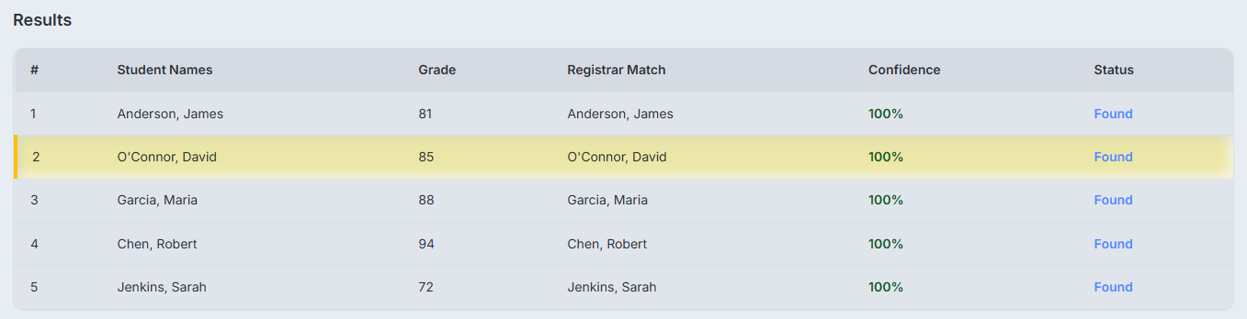

4) Last Name, First Name

Teacher’s List | Registrar List
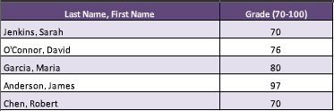 | 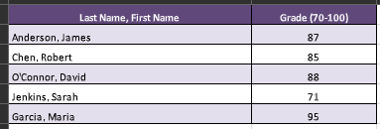

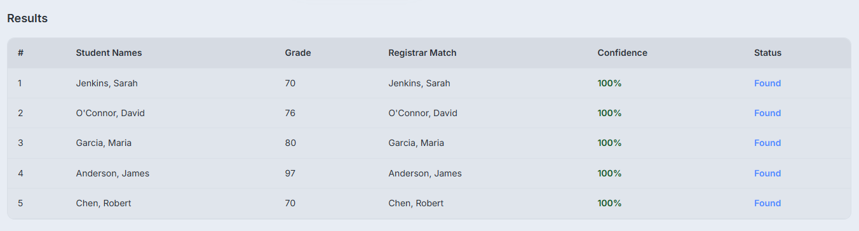

5) Combined format (Split Names & Last Name, First Name)

Teacher’s List | Registrar List
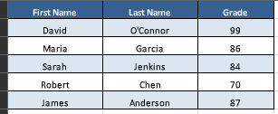 | 

